**CSCE 5320: Scientific Data Visualization**

**Increment 1**

**Video Link :-** <https://drive.google.com/file/d/1WC6cW9_og5Ch9cz7oAH8Xkaxgio4dhcX/view?usp=sharing>

**Title :- Inflation at a Global Level**

**Team :-**

Aniv Chakravarty ([anivchakravarty@my.unt.edu](mailto:anivchakravarty@my.unt.edu)):-

* Data Cleaning
* Analyzing data using basic visualizations.
* Researching possible visualization strategies for dashboard.
* Implementation of certain parts of dashboard

Shridhar Kshirsagar ([shridharkshirsagar@my.unt.edu](mailto:shridharkshirsagar@my.unt.edu)):-

* Research on data to be presented to the user via dashboard which will provide meaningful domain/business insights.
* Making the dashboard more interactive and user friendly.
* Implementation of Dashboard using a programming language.

**Motivation:-**

* Economy of a nation plays an important role in deciding the essential factors contributing to its growth. On a democratic scale, it widens the gap between the nation’s government and its citizens. On a citizen level, inflation may have a considerable impact on the belief of people in their government.
* Tracking inflation in a country is as valuable as tracking the rapidly changing stock market.
* Although, there still hasn’t been a proper utilization of data analytics resources to study and predict the inflation at a global level, when compared to the booming field that is stock market prediction.
* Hence, we propose a system to track and understand the nature and trends of inflation at a global level using different Data Analytics and Visualization techniques.
* Tracking inflation can be beneficial at many levels. One of the advantages being that the government can plan better ahead of time to take care of the fact that the impact on its citizens is cut down to bare minimum.
* Additionally, it will also enable the authorities to investigate and tackle the root of inflation due to a better understanding ahead of time.
* At a citizen level, this system will help the people to be more aware of the financial situation of their country as well as make necessary amends and preparations.

**Significance:-**

We observed various different plots created visualizing different aspects of the inflation data through different line, bar and geographical plots [[2](https://inflationdata.com/inflation/images/)] as well as customized line plots for depicting income as in [[3](https://www.anychart.com/blog/2021/11/12/visualizing-data-prices-emissions-workforce-palm-oil/#more-13940)]. The closest dashboard we found online was from the international monetary fund [[4](https://www.imf.org/external/datamapper/PCPIPCH@WEO/OEMDC/ADVEC/WEOWORLD)] which provides an interactive interface for geographic heatmap with a line scale trend for displaying average economic data but does not break down by different economic sectors and visual and the global inflation rate tracker [[5](https://www.ft.com/content/088d3368-bb8b-4ff3-9df7-a7680d4d81b2)] which made use of line and geographic plots for fixed years and a few major countries. We aim to provide a dashboard with few more visualizations compared to these. These visualizations do not provide much room to drill down and drill up on the data with limited interactivity in terms of mouse clicks. While these front end dashboards provide great visualizations our project aims to provide a more interactive approach with more ways to view the data.

**Objectives:-**

Our objective is to build a tool, analyse the data and find answers to key questions such as,

* What is the current rate of inflation?
* Which countries have the highest inflation rate? and
* What are the trends for each country?

We also need to provide the data in crisp, easy to understand visualizations in an interactive dashboard.

For the first increment we plan on doing exploratory data analysis and building the application.

For the second increment we will be adding the extra features and user interface.

**WorkFlow:-**

We first start with cleaning the dataset. Once the data is ready we perform exploratory analysis on different visualization forms to pick a set of visualizations to have in the application. Figure 1 shows the workflow of our project plan. The story boarding process in the user interface and experience would determine what the user sees and how the user interacts with the main dashboard and respective features as they are added and would be tied to development. We will build a core set of features for the initial phase 1 of the project so that the app works first, we then proceed with the iterative cycles to add in further features. The analysis portion would be to determine which visualizations provide the details in an understandable format in order to avoid excessive clutter on the dashboard. We plan to first start with barcharts, spheres, scatterplots and then branch out to more complex plots.

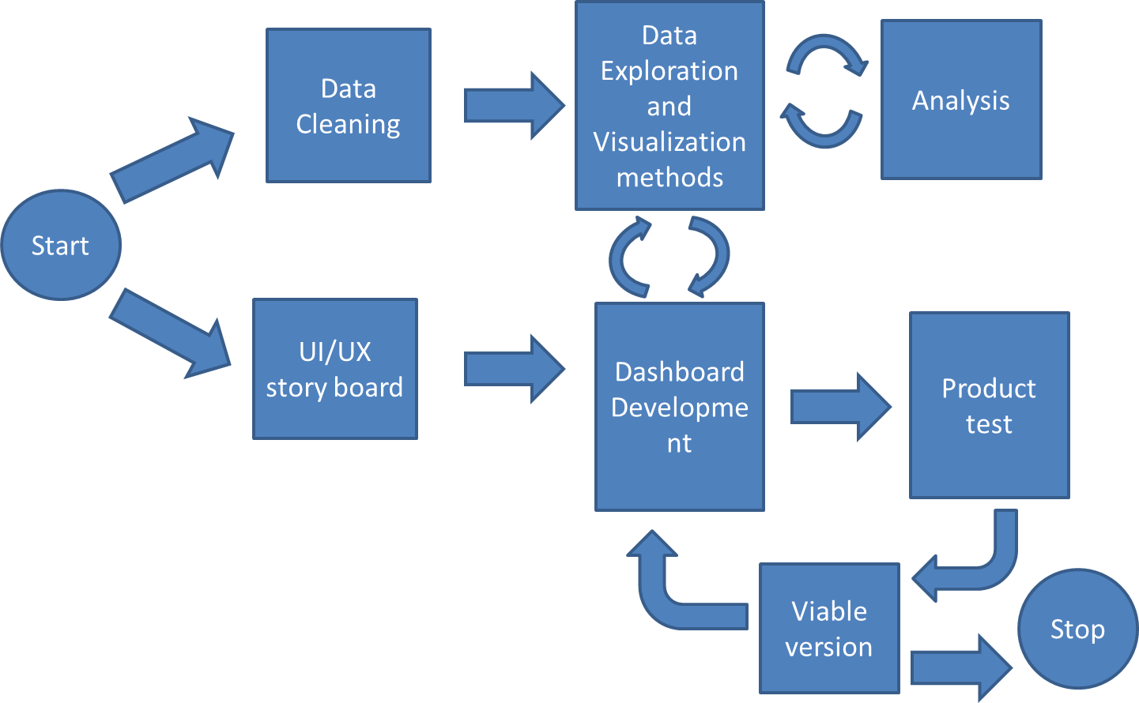

Figure 1: Project Workflow

In terms of data workflow, our dashboard will be fetching quantitative data from a storage repository while having an interactive module and sub visualizations that would form supplementary visualizations on context based on Figure 2. While this is an initial proposal our workflow may change based on how our ui/ux storyboard goes through and update based on that.

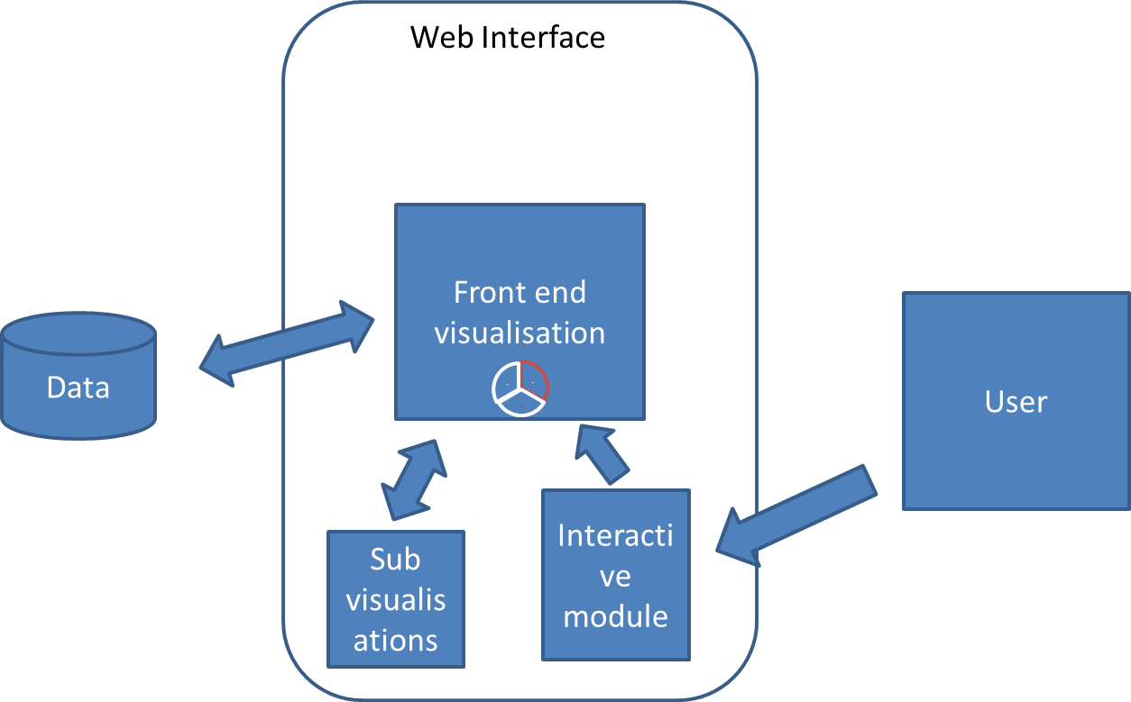

Figure 2: System Workflow

**Features:-**

The dataset [[1](https://www.kaggle.com/datasets/belayethossainds/global-inflation-dataset-212-country-19702022)] contains inflation data of over 206 countries in the time frame of 1970 to 2022 across four domains of consumer, producer, food, energy costs. This allows us a lot of room in terms of visualization of the data. So we plan to try and incorporate the feature listed below in our tool in an iterative method starting with core visualization parts first and adding features on top.

* Drill up and drill down options
* Navigation
* Interactive visualization
* Dashboard user interface
* Dynamic visualization changer
* Annotation options
* Multiple panels
* Colorblind features
* Customization options
* Web application
* Feature engineering options to perform grouping, numerical operations on the data.
* Animations
* Print report

Github: <https://github.com/AnivChakravarty/global_inflation_viz>

Contributors : AnivChakravarty and cosmos225(Shridhar Kshirsagar)

**Increment 1:**

**Domain:-**

The domain of our project covers geospatial as well as economical as we work to visualise and analyse the data of inflation rates on a global scale across multiple countries throughout multiple years.

**Data Abstraction:-**

Our data consists of numerical data across multiple sub categories and years.

Our data consists of

1. Country code: string, categorical data type holds the country code of the country
2. IMF Country code: float64 numeric value representing the country code.
3. Series Name: This field represents string, categorical data to the sub category domains of inflation
4. 1970-2022: these float64 fields represent the values among the countries and subcategories through the years 1970 to 2022
5. Notes: these are string data of extra notes for the subcategories.

Data abstraction is done by first getting the average of inflation throughout all the subcategories for each country for each year.

In order to make the data easier to read for time series the data is pivot and grouped for years.

This gives us an easier dataset to work with.

We abstract with a world map visualisation with a choropleth map where the values are the average inflation of each country for that year.

**Task Abstraction:-**

Our plan was to initially build the ui dashboard and embed our visualisations into the dashboard windows.

**Task 1**: Geographical map with inflation rates

Description: Generate an interactive world map that shows inflation rates by year

Action: the map is a spatial choropleth map from 1970 to 2022 using a reusable plot using a dropdown for changing map plots.

**Task 2**: Generate a pie chart for the top 10 countries where inflation is the most

Description: Build a pie chart to visualise the top 10 countries where inflation is high.

Action: interactivity needs to be able to show the information on hover.

**Task 3**: Build a bar chart for top 10 high inflation countries.

Description: The bar chart is a visual for top 10 countries where inflation is high.

Action:Based on the inflation rates obtained for a particular year, we create a bar chart to view the amount of inflation in the top 10 countries.

In terms of data processing our tasks are

**Task 4**: Clean data

Description: The dataset consists of extra fields that hold no value or empty values.

Action: Clearing out unnecessary value, pivot and grouping data as well as aggregating average fields of each country while replacing null average to 0.

For Dashboard UI,

**Task 5**: build a dashboard

Description: we need to build a dashboard that can be accessed via web browser.

Action: We made use of the python dash library to build our dashboard in a jupyter notebook that is accessed via browser url.

**Implementation using tools:**

The implementation of our dashboard and visualisations is done using python, notebooks like jupyter , javascript and plotly library.

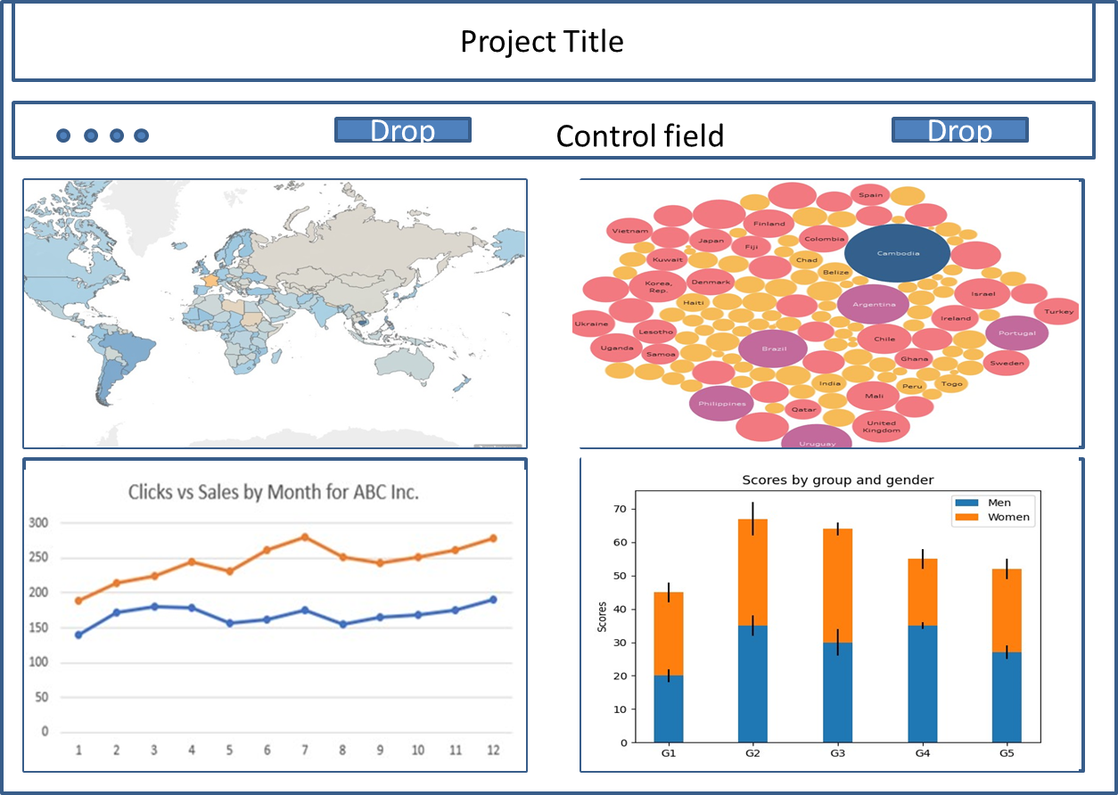

Figure 3: Dashboard design prototype

Initially we plan of having a web browser based dashboard as Figure 3 with a primary world map based spatial choropleth with additional plots on windows for added data refinement.

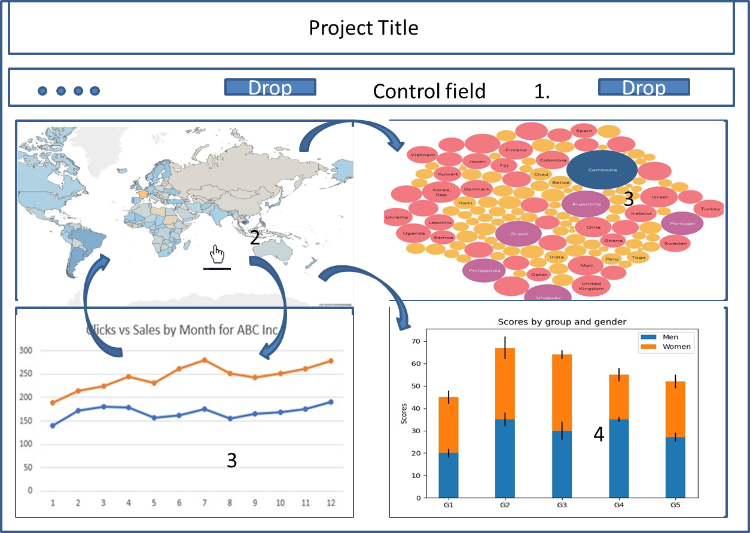

Figure 4: storyboard interaction view of dashboard

Figure 4 represents how the user would interact with the dashboard. The user starts with loading a map year from the drop down in step 1. This populates the map and starts the interaction of the map in step 2. The time plot populates and can be used to update the map as well from step 3. Step 4 and 5 populate from actions of 1,2 and

**Preliminary Results for Analysis:**

While we are still working on improving the dashboard and adding more features as per our intended design, we have been able to build the initial capability of loading the choropleths(Figure 5) and subsequent charts (Figure 6) with a drop down widget.

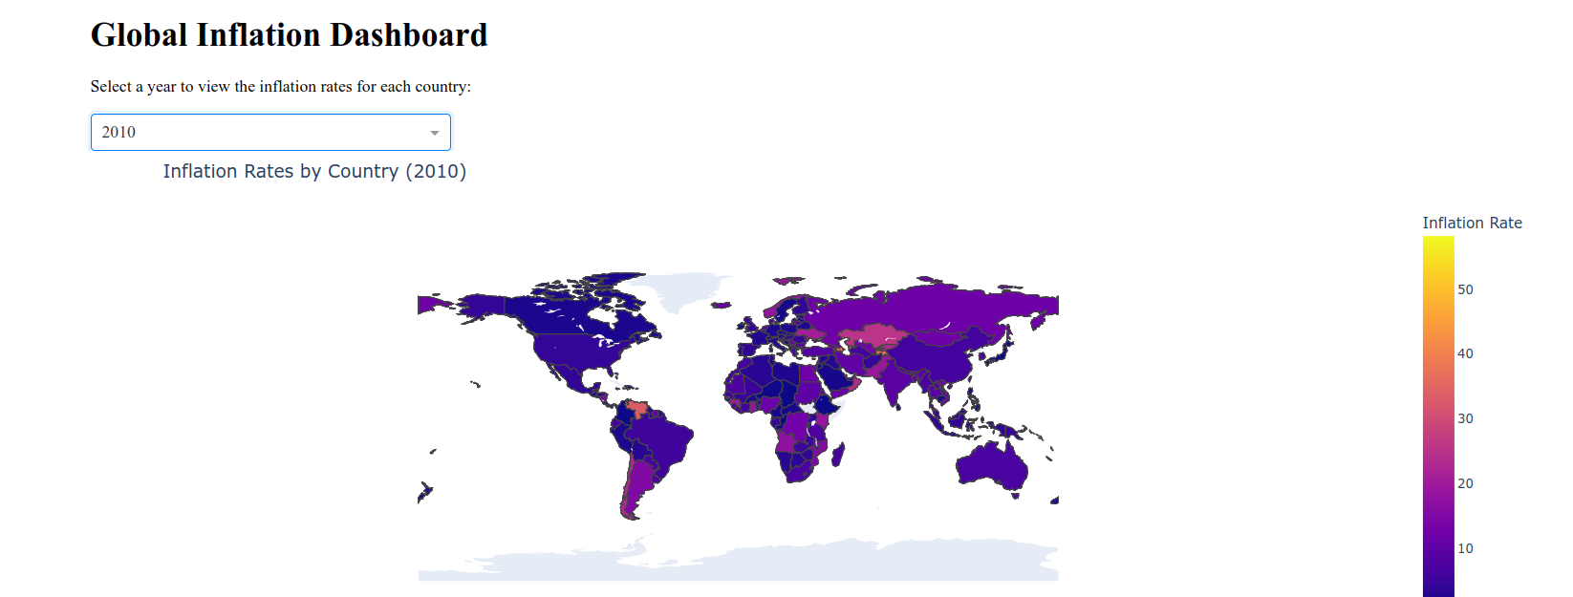

Figure 5: Dashboard Implementation-choropleth

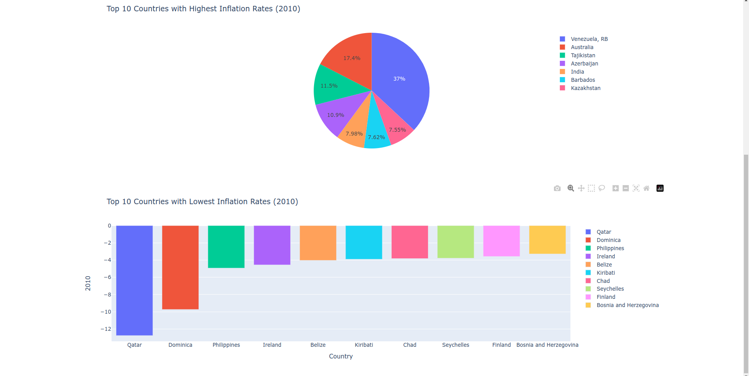

Figure 6. Dashboard Implementation-pie chart and bar chart

The piechart and bar plot are fetched from the data based on year and provide detailed descriptions of the data from the primary map using countries as channels and their respective quantities as marks.

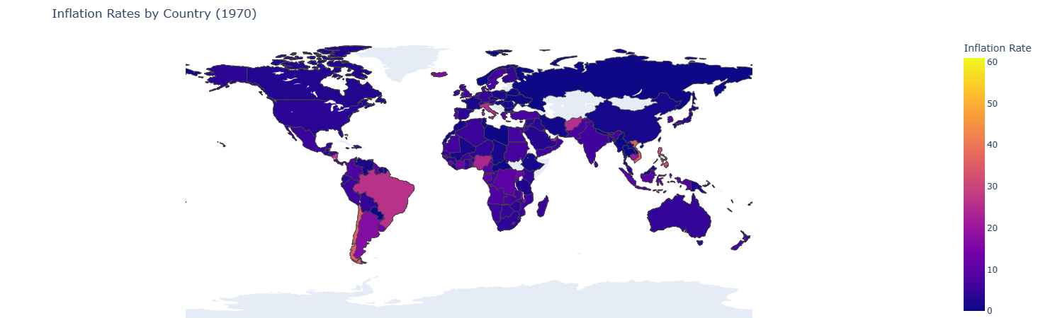

Figure 7: Choropleth 1970

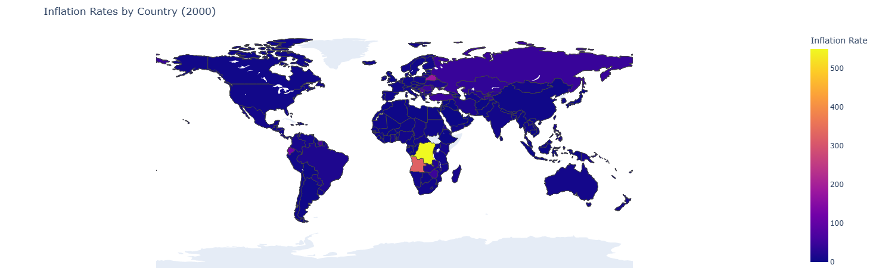

Figure 8: Choropleth 2000

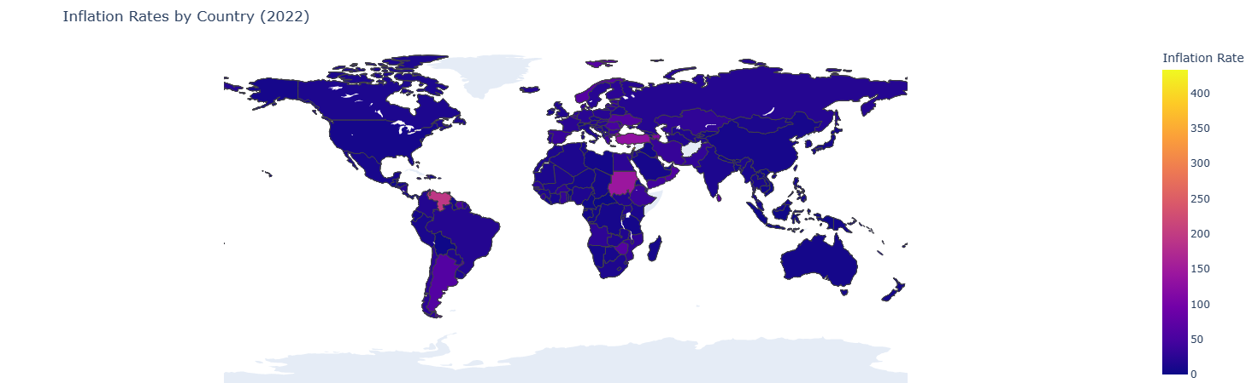

Figure 9: Choropleth 2022

Since our data covers the range from 1970 to 2022 we see three main plots of inflation from 1970, 2000 and 2022 from Figures 7,8 and 9. From the plots we see that there is a constant inflation rise in africa and central europe as well as some portions of south america. While there was a rise in inflation rates in the middle eastern countries it seems to have slowed down. Choropleths are useful for top level visuals of giving a brief summary.

**Project Management:**

In terms of our progress we provide two sections of work completed and work to be completed along with the respective person who completed said work or is responsible for completing it in brackets next to the task. Given that we have a working dashboard with some of the key plots being visualised we can start to focus a bit on interactivity while wrapping up a few remaining design points.

**Work completed:**

* Data cleaning: Data cleaning involves removal of unnecessary columns, grouping and preparation of aggregate values of inflation rate.(Aniv)
* Visualisation exploration: After looking through multiple visuals we saw cholorpleth global map, line plots were commonly used for this type of spatial data. Along with these plots we saw additional plots of bubble plots, bar plots, boxplots can also be used. Further we saw that pie charts can also be used to represent the various subcategories.(Aniv)
* Designing a storyboard and interaction plan as well as basic dashboard design.(Aniv)
* Building dashboard(Shridhar)
* Testing web accessibility(Shridhar)
* Dynamic plots(Shridhar)
* Save plots(Shridhar)

**Work to be completed**

* Building interactive world map in altair and plotly(Aniv)
* Building interactive bubble plot in altair and plotly(Aniv)
* Building interactive line plot in altair and plotly(Aniv)
* Building interactive box plot in altair and plotly(Aniv)
* Embed plots to dashboard(Shridhar)
* Test online browser functionality of plots(Shridhar)
* Test plot links(shridhar)
* Drill down and up feature(Shridhar)
* Going over features(both)
* Analysis(both)
* Documentation(both)

**Issues and Concerns:**

A lot of features were initially posted and while we aim to implement most of them we realise that time may be an issue so we are still focusing on getting the core interactive functionality in place with multiple plots as well as reviewing design decisions we have since our current working model is one plot after another with a scroll window. Challenges include making effective use of screen space and interactive functionality.

**References:**

1. “Global Inflation Dataset - (1970~2022).” *Kaggle*, <https://www.kaggle.com/datasets/belayethossainds/global-inflation-dataset-212-country-19702022>. Accessed 16 April 2023.

2.“Global inflation tracker: see how your country compares on rising prices.” *Financial Times*, 12 April 2023, <https://www.ft.com/content/088d3368-bb8b-4ff3-9df7-a7680d4d81b2>. Accessed 16 April 2023.

3.McMahon, Tim. “Inflation Charts and Graphs.” *InflationData.com*, 14 March 2023, <https://inflationdata.com/inflation/images/>. Accessed 16 April 2023.

4.“Visualizing Data on Prices, Emissions, Workforce, Palm Oil | DataViz Weekly.” *AnyChart*, 12 November 2021, <https://www.anychart.com/blog/2021/11/12/visualizing-data-prices-emissions-workforce-palm-oil/#more-13940>. Accessed 16 April 2023.

5.“World Economic Outlook (April 2023) - Inflation rate, average consumer prices.” *International Monetary Fund*, <https://www.imf.org/external/datamapper/PCPIPCH@WEO/OEMDC/ADVEC/WEOWORLD>. Accessed 16 April 2023.